PHP Notes Chapter 10 Databases and SQL

PHP uses extensions to interact with a range of databases. For example, to interact with the MySQL database, you can use the functions provided by the mysqli extension.
PHP also offers abstraction layers that provide an application layer between your code and the database (like PDO, PHP Data Object).
Apart from relational databases MongoDB is a very popular NoSQL database and it has contributed a driver for PHP that allows you to connect to the database. However for the exam this in not likely to be included

Database Basics
Keys
Keys impose constraints, such as PRIMARY and UNIQUE. A primary key can be defined on either a single or multiple columns. It guarantees that each row in the database will have a unique value combination for the columns in the key. A row may not have a null value for its primary key.
A table may have only one primary key. A foreign key can also be defined on either a single or multiple columns. It references the primary key on another table. This is a unique reference, so only one row in the referenced table will be linked to the table containing the foreign key.
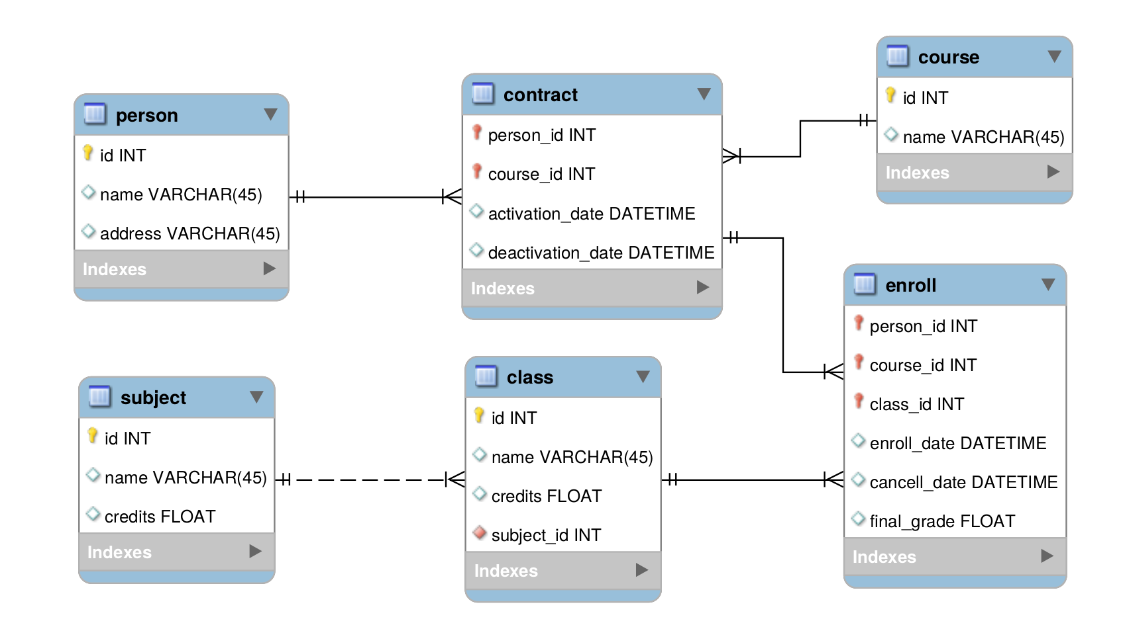
Indexes
Indexes are data structures that are needed to implement the key constraint.
Indexes make retrieving records faster. The database engine will create a structure on disk or in memory that contains the data from the indexed columns. This structure is optimized forlookups and helps the database find the row in the table faster.
Whenever you insert a row into a table, the indexes need to be updated. This adds an overhead to writing.
You cannot have a key without an index, but it is possible to index columns that are not keyed.
You would do this in cases where you don't want to enforce uniqueness but do want to speed up SELECT statements that include these columns in their WHERE clauses.

Relationships
Relationships are a core feature of relational databases. By declaring how tables are related, you can enforce referential integrity and minimize dirty data.
There are several types of relationships.
Relationship Description
One-to-one One row in the parent table can reference exactly one row in the child table.
One-to-many One row in the parent table can be referenced by many rows in the child table.
Many-to-many Any number of rows in the parent ta

SQL Data Types
Columns in a SQL database table have a data type assigned to them.
Each database manager will implement the SQL data types slightly differently and will have different optimizations between its types.

Integers Types
The types of integers vary in the amount of bytes that they take to store their value. The following table illustrates the sizes of integers for the MySQL database

Integer Type Bytes (Signed) Values (Unsigned) Values
BIGINT 8 -9223372036854775808 to 0 to 18446744073709551615
+9223372036854775807
INTEGER 4 -2147483648 to +2147483647 0 to 4294967295
MEDIUMINT 3 -8388608 to +8388607 0 to 16777215
SMALLINT 2 -32768 to +32767 0 to 65535
TINYINT 1 -128 to +127 0 to 255

NUMERIC and DECIMAL Types
Non-integer types can be stored in either NUMERIC or DECIMAL values.
The SQL-92 standard specifies that a NUMERIC type must have the exact precision stipulated, while the DECIMAL type must be at least as precise. The implementation of these data types does differ between vendors.
They both take the same parameters: NUMERIC(21,3)
The first parameter specifies the total number of digits of precision, and the second parameter specifies how many digits of decimal precision must be stored.

Character Types
SQL allows for character to be stored either in fixed or variable length strings.
A fixed-length string is always allocated the same number of bytes on disk. This can help speed up read performance in some database implementations.
Variable-length strings can swell up to the limiting size given to them. The database engine allocates storage according to the length of the string.

Working with SQL
Creating a Database and Table
The CREATE statement can be used to create databases and tables. To creating a database you just specify the name of the database:
CREATE DATABASE mydatabase;
When creating a table, you can specify a list of the columns you want to store in it.
For each column, you specify the:
                - Name,
                - Data type, &
                - Attributes.

CREATE TABLE IF NOT EXISTS users (
id int unsigned NOT NULL AUTO_INCREMENT,
name varchar(255) NOT NULL,
email varchar(255) NOT NULL,
pass varchar(60) NOT NULL,
PRIMARY KEY (id),
UNIQUE KEY users_email_unique (email)
);

Dropping Database and Tables
The inverse of CREATE is the DROP statement.
DROP TABLE category;
DROP DATABASE mydatabase;
If you have specified foreign keys, the database will not let you drop a table if this will violate one of the constraints.

Retrieving Data
The SELECT statement is used to retrieve data.
In this simple pseudo-code example of a query, we retrieve the names of products from our table that cost more than 100 currency units.
We specify that we want the results to be returned in descending order of price.

SELECT name
FROM products
WHERE price > 100
ORDER BY price DESC

Inserting New Data
The INSERT statement is used to create new rows in the database.
You will need to provide a list of the columns and the values to insert to them.
Columns that are marked NOT NULL are mandatory and must have a value specified when you create the row.

INSERT INTO products
(name, price, category_id) VALUES
('cheeseburger', 100, 3)

If you don’t specify the names of the columns, SQL will assume that you’re providing values in the order that the columns appear in the table.

Updating Data
The UPDATE statement accepts a list of values , as well as an optional WHERE clause .
You must specify what values to update the existing data to, and the criteria for the rows that must be updated.
UPDATE products
SET price = price + 100
WHERE category_id = 3;
Aggregating Data
You can use the database to perform calculations and send you the results.

Statement Returns
AVG Average value of the data values
SUM Total of all the data values found
COUNT How many records were found
DISTINCT COUNT How many unique records were found
MIN The lowest value in the data set
MAX The highest value in the data set

Using these functions looks as follows:
SELECT AVG(price) FROM products;

Grouping Data
You can tell SQL to group data by a column or combination of columns before returning it to you.
This is often useful in conjunction with the aggregating functions.

An example where we want to find out the total amount of sales that each of our customers has purchased:

SELECT email, SUM( sales_value )
FROM `transactions`
GROUP BY email

Joins
Joins are used to connect tables based on supplied criteria. This lets you retrieve information from related tables.
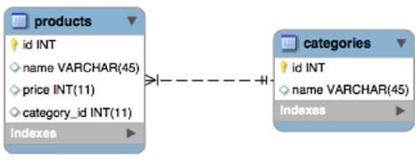
In the products and categories database, you can retrieve the category name of products by joining the categories table to the products table:
SELECT *
FROM products
JOIN categories ON categories.id = products.category_id
Join Types
There are several ways to join tables.
Join Type Effect
INNER JOIN Selects records that have matching values in both tables, as in the previous example
LEFT OUTER JOIN Selects tables from the left table that have matching right table records
RIGHT OUTER JOIN Selects records from the right table that have matching left table records
FULL OUTER JOIN Selects all records that match either left or right table records
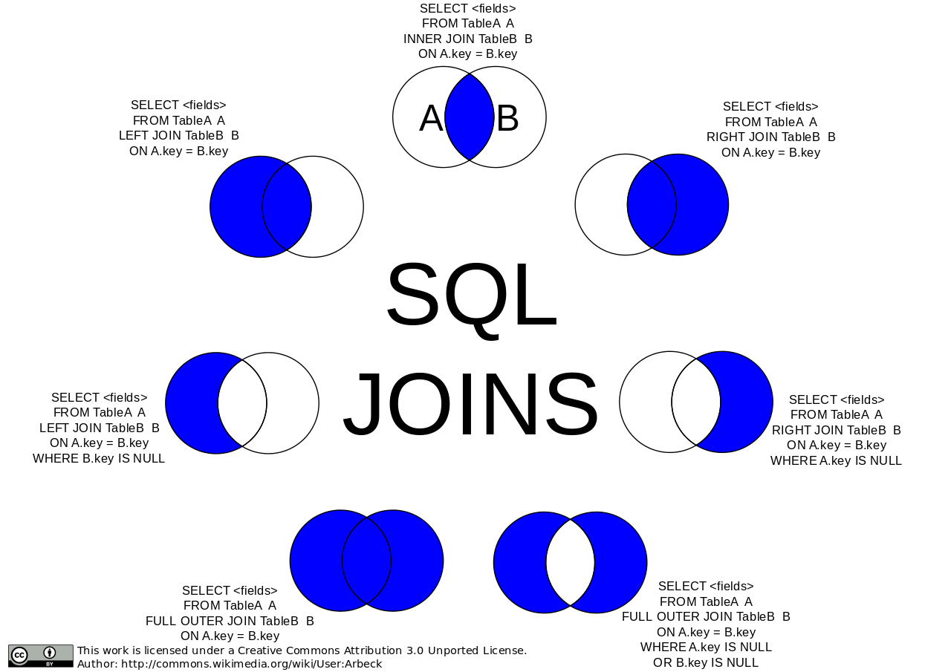

Prepared Statements
When issueing a command to a SQL engine, it must parse the command in order to execute it.
After the statement has been executed, SQL will discard the compiled code with the result that repeated calls with the same SQL command will need to be parsed individually.
Obviously, this results in duplicated effort.
You can save SQL from having to repeat its efforts by using prepared statements that become parsed code templates that SQL stores for multiple reuse.
Prepared statements also offer significant security advantages.
Parameters are bound to the prepared statement, and are not included as part of the code string.
This means that it is not possible for your parameters to intrude on the code, which means that you no longer need to worry about escaping code to prevent SQL injection.
Just keep in mind the possibility of stored XSS attacks before you stop worrying about escaping data coming into or out of your database.

Example 1:
?php
// prepare and bind
$stmt = $conn->prepare("INSERT INTO users (username, password) VALUES (?, ?)");
$stmt->bind_param("ss", $username, $password);

// set parameters
$username = "bob";
$password = password_hash("password", PASSWORD_BCRYPT);

// run the statement
$stmt->execute();
?>

Transactions

A transaction is a set of SQL statements that will either all succeed or else have no effect.
After a transaction finishes the database must not have any table constraints invalidated and must be in a state where all the changes have been persisted.
A database must have some way of ensuring that transactions can run at the same time and not interfere with each other. For example: It can’t increment a primary key that another transaction is depending on.
In summary, a transaction is a set of SQL statements that must complete successfully in an “all or nothing” manner.
After it runs the database must be in a consistent state and must be recoverable from error.
The syntax for transactions varies between vendors, but there are three important statements.

- One statement will mark the beginning of the transaction block. The SQL statements following this will be part of the transaction.
- There are two statements that can end a transaction. One of them will tell SQL to go ahead and make all the changes that the transaction is making.
- The other end statement will tell SQL that for whatever reason you want to abandon the transaction and rather revert to the state the database was in when the transaction started.

Here are the three most common vendor statements:
MySQL MS-SQL ORACLE
START TRANSACTION BEGIN TRANSACTION START TRANSACTION
COMMIT COMMIT TRANSACTION COMMIT
ROLLBACK ROLLBACK WORK ROLLBACK

PHP Data Object (PDO)
The PDO extension defines a lightweight, consistent interface for accessing databases in PHP.
PDO provides a data-access abstraction layer; which means that, regardless of which database you're using, you use the same functions to issue queries and fetch data.
PDO does not provide a database abstraction; it doesn't rewrite SQL or emulate missing features. You should use a full-blown abstraction layer if you need that facility.
The SQL that you pass to the PDO::query() or prepared statements must be valid for the vendor you are connecting to.
PDO uses database adapters to connect to the database. These adapter classes implement PDO interfaces and expose vendor-specific functions as regular extension functions.
Note: that you cannot perform any database functions using the PDO extension by itself; you must use a database-specific PDO driver to access a database server.
PDO is configured in the PHP configuration file. At runtime, you can change options with the PDO::setAttribute() function.

Classes

① The PDO class ② The PDOStatement class ③ The PDOException class

The PDO class
Represents a connection between PHP and a database server.
class PDO {
public __construct(
str $dsn, ?str $username = null, ?str $password = null, ?arr $options = null
)
... ...
... ...
}

Method Description
PDO::__construct Creates a PDO instance representing a connection to a database

PDO::setAttribute Set an attribute
PDO::getAttribute Retrieve a database connection attribute
PDO::getAvailableDrivers Return an array of available PDO drivers

PDO::prepare Prepares a statement for execution and returns a statement object
PDO::query Prepares and executes an SQL statement without placeholders
PDO::quote Quotes a string for use in a query
PDO::exec Execute an SQL statement and return the number of affected rows
PDO::lastInsertId Returns the ID of the last inserted row or sequence value

PDO::beginTransaction Initiates a transaction
PDO::inTransaction Checks if inside a transaction
PDO::rollBack Rolls back a transaction
PDO::commit Commits a transaction

PDO::errorCode Fetch the SQLSTATE associated with the last operation on the database handle
PDO::errorInfo Fetch extended error information associated with the last operation on the database handle

Connecting to PDO
To connect to a database withPDO, you create an instance of the PDO class.
The constructor accepts: parameters for the database source (DSN), the username and the password if these are required.

<?php
try {
$dbh = new PDO('mysql:host=localhost;dbname=test', $user, $pass);
} catch (PDOException $e) {
echo "Error connecting to database: " . $e->getMessage();
}

If there are errors connecting to the database then a PDOException will be thrown.

NOTE: It is very important to note that the stack trace of the exception will probably contain the full database connection details. Make sure that you catch it and don’t let it be displayed RAW.

To close a connection when you're done with it, you can set the PDO variable to null:
$dbh = null;

Database connections are automatically closed at the end of your running script unless you make them persistent.
Persistent database connections are not closed but are instead cached for another instance of the script to use.
This reduces the overhead of needing to connect to the database every time your web application runs.

Transactions in PDO
PDO offers transaction commands too ( but does not emulate proper transaction handling ). This means that you can only use the PDO transaction functions on databases that natively support transactions.
The functions are: ① PDO::beginTransaction(), ② PDO::commit(), and ③ PDO::rollBack().

Example 2:
<?php
$dsn = 'mysql:host=localhost;dbname=example';
$pdo = new PDO($dsn, 'dbuser', 'dbpass');
$pdo->setAttribute(PDO::ATTR_EMULATE_PREPARES, TRUE);
$pdo->setAttribute(PDO::ATTR_ERRMODE, PDO::ERRMODE_EXCEPTION);
$password = password_hash("password", PASSWORD_BCRYPT);
try {
$pdo->beginTransaction();
$pdo->exec(" INSERT INTO users (username, password)
VALUES('bob', '{$password}'");
$pdo->commit();
} catch (PDOException $e) {
$pdo->rollBack();
echo 'Rolled back because: ' . $e->getMessage(); }
Commen Attribute

$pdo->setAttribute(PDO::ATTR_EMULATE_PREPARES, TRUE);

Enables or disables emulation of prepared statements.
PDO can run your queries in two ways:
- It can use a real or native prepared statement:
When prepare() is called, your query with placeholders gets sent to mysql as is, with all the question marks you put in (in case named placeholders are used, they are substituted with ?s as well), while actual data goes later, when execute() is called.
- It can use emulated prepared statement, when your query is sent to mysql as proper SQL, with all the data in place, properly formatted. In this case only one roundtrip to database happens, with execute() call. For some drivers (including mysql) emulation mode is turned ON by default.

Some drivers do not support native prepared statements or have limited support for them.
When set to True PDO will always emulate prepared statements.
When False PDO will try to use native prepared statements.
It will always fall back to emulating the prepared statement if the driver cannot successfully prepare the current query.

$pdo->setAttribute(PDO::ATTR_ERRMODE, PDO::ERRMODE_EXCEPTION);
PDO::ATTR_ERRMODE: This attribute is used for error reporting. It can have one of the following values.
PDO::ERRMODE_SILENT: If the ATTR_ERRMODE is not set in the code, ERRMODE_SILENT is the default value of ATTR_ERRMODE attribute. It sets error codes. In silent mode, if there is an error in SQL, PDO will throw no exceptions; PDO will issue no warnings; it will simply return false. Value of PDO::ERRMODE_SILENT is 0. The script will run without generating any error or warning.
PDO::ERRMODE_WARNING: This value raises E_WARNING. In warning mode, if there is an error in SQL, PDO will issue warnings but script will continue running. Value of PDO::ERRMODE_WARNING is 1. The script will run with generating warning about the error.
PDO::ERRMODE_EXCEPTION: This value throws exceptions. In exception mode, if there is an error in SQL, PDO will throw exceptions and script will stop running. Value of PDO::ERRMODE_EXCEPTION is 2. The script will stop executing generating the error which throws the exception.

The PDOStatement class
In the first example when we did:
$stmt = $conn->prepare("INSERT INTO users (username, password) VALUES (?, ?)");
$stmt->bind_param("ss", $username, $password);
$username = "bob"; $password = $password_hash("password", PASSWORD_BCRYPT);
$stmt->execute();
The $conn is an instance of PDO, when PDO::prepare or the PDO::query methods they will return a PDOStatement instance which in this case is $stmt.
The binding is being done from the PDOStatement instance not the PDO instance. (And in this case, also the execution).

PDOStatement binding methos:
PDOStatement:bind_param(), PDOStatement:bindColumn() and PDOStatement:bindValue()

Execting methods:
Both classes can execute statements. However one executes SQL statements and the other Prepared statement. Also not both can fetch data back from the database:
PDOStatement::execute() — Executes a prepared statement and return the number of affected rows.
public PDOStatement::execute(?array $params = null): bool
PDOStatement::bindParam() and/or PDOStatement::bindValue() has to be called to bind either variables or values (respectively) to the parameter markers.

PDOStatement::execute() Get data from the databse (return results) which can the fetched by the methods:
PDOStatement::fetch(),
PDOStatement::fetchAll(),
PDOStatement::fetchColumn() &
PDOStatement::fetchObject()

PDO::exec() — Execute an SQL statement and return the number of affected rows.
public PDO::exec(string $statement): int|false
PDO::exec() does not return results from a SELECT statement.

// compare with prepared statment:
$password = password_hash("password", PASSWORD_BCRYPT);
$conn->exec("INSERT INTO users (username, password) VALUES('bob', '{$password}'");
PDO::prepare VS PDO::query:
PDO::query — Prepares and executes an SQL statement without placeholders
Example 3:
<?php
$sql = 'SELECT name, color, calories FROM fruit ORDER BY name';
foreach ($conn->query($sql) as $row) {
print $row['name'] . "\t";
print $row['color'] . "\t";
print $row['calories'] . "\n";
}
?>
apple red 150
banana yellow 250
kiwi brown 75
lemon yellow 25
orange orange 300
pear green 150
watermelon pink 90

Following flow chart is just a guide to help you determine which you should be using for any given situation:
(However the Prepared statement is always the safest way)
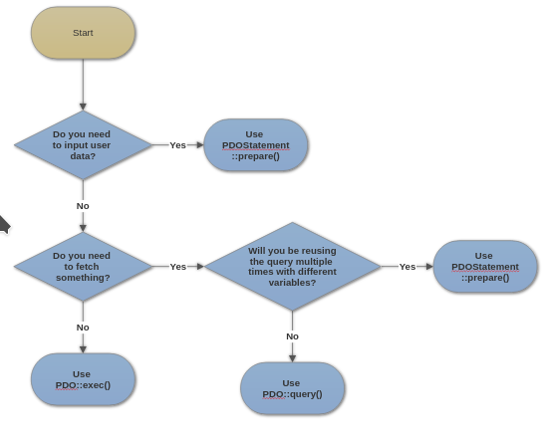

Recapture on the the PDOStatement class
PDOStatement class represents a prepared statement and, after the statement is executed, an associated result set.

class PDOStatement implements Traversable {
// Properties
readonly string $queryString;
// Methods
public bindValue(string|int $param, mixed $value, int $type = PDO::PARAM_STR): bool
public bindParam(string|int $param, mixed &$var,int $type = PDO::PARAM_STR,
int $maxLength = 0, mixed $driverOptions = null
... ...

Method Description
PDOStatement::bindColumn Bind a column to a PHP variable
PDOStatement::bindParam Binds a parameter to the specified variable name
PDOStatement::bindValue Binds a value to a parameter

PDOStatement::execute Executes a prepared statement

PDOStatement::fetch Fetches the next row from a result set
PDOStatement::fetchAll Returns an array containing all of the result set rows
PDOStatement::fetchColumn Returns a single column from the next row of a result set
PDOStatement::fetchObject Fetches the next row and returns it as an object
PDOStatement::setFetchMode Set the default fetch mode for this statement

PDOStatement::columnCount Returns the number of columns in the result set
PDOStatement::rowCount Returns the number of rows affected by the last SQL statement

PDOStatement::debugDumpParams Dump an SQL prepared command
PDOStatement::errorCode Fetch the SQLSTATE associated with the last operation on the statement handle
PDOStatement::errorInfo Fetch extended error information associated with the last operation on the statement handle

redMANTIS*963_s

bindParam & bindValue

The PDOStatement::bindParam and PDOStatement::bindValue methods are both use in binding a variable to a parameter
Although they’re quite similar, they differ in how they work.
bindParam binds a parameter to a specified variable name by reference.
bindValue binds a value which could be a variable, an integer or string to a parameter by value.
< ?php
$name = 'collins';
$sql = 'INSERT INTO feeds (name) VALUES (:name)';
$update = $conn -> prepare($sql);
$update -> bindValue(':name', $name);
$update -> execute();
Thus, we can still change the value of a variable bonded to a parameter even after the bindParam() method had been called like so:
$name = 'collins';
$sql = 'INSERT INTO feeds (name) VALUES (:name)';
$update = $conn -> prepare($sql);
$update -> bindParam(':name', $name);
$name = 'john';
$update -> execute(); // execute with john inserted into the column "name"
However “bindValue” accept vary data types.
< ?php
$sql = 'INSERT INTO feeds (names) VALUES (:name, :age)';
$update = $conn -> prepare($sql);
$update -> bindValue(':name', 'collins');
$update -> bindValue(':age', 100 );
$update -> execute();
When you try to bind say, a string or number (float / integer) to a parameter using bindParam, you’ll get this error: Fatal error: Cannot pass parameter 2 by reference
https://w3guy.com/php-pdostatement-bindparam-bindvalue/

Positional placeholders (?) or Named placeholders (:parameter)
Using Positional placeholders:
$sql = 'insert into authors(first_name, last_name) values(?,?)';
$statement = $pdo -> prepare($sql);
$statement -> execute(['Sandra', 'Aamodt']);
Using Named placeholders:
$sql = 'insert into authors(first_name, last_name) values(:first_name,:last_name)';
$statement = $pdo -> prepare($sql);
$statement->execute([ ':last_name' => 'Aaron', ':first_name' => 'Henry', ]);
The colon (:) is required in the SQL statement. However it is optionally used in the array.
$statement->execute([ 'last_name' => 'Aaron', 'first_name' => 'Henry', ]);

In the above examples, we pass the values to the execute() method to run the query. These statements are called unbound statements.

In bound statements this example will look as followes:
Positional placeholders:
$sql = 'insert into authors(first_name, last_name) values(?,?)';
$statement = $pdo -> prepare($sql);
$statement->bindValue(1, 'Nick');
$statement->bindValue(2, 'Abadzis');
$statement -> execute();
Named placeholders:
$sql = 'insert into authors(first_name, last_name) values(:first_name,:last_name)';
$statement = $pdo -> prepare($sql);
$statement->bindValue(':first_name', 'Nick');
$statement->bindValue(':last_name', 'Abadzis');
$statement->execute();

Note: You can only bind scalar values, not composite variables like arrays or objects.
- Use a PHP prepared statement to execute a query multiple times with different values.
- Use positional placeholders (?) or named placeholders (:parameter) in the SQL statement before passing it the prepare() method of an PDOStatement object.
- Use the execute() method with values to run an unbound statement.
- Use bindValue() or bindParam() method to bind values to a bound statement.
Fetching PDO Results
PDOStatement::fetch() — Fetches the next row from a PDO result set

public PDOStatement::fetch(int $mode = PDO::FETCH_DEFAULT,
int $cursorOrientation = PDO::FETCH_ORI_NEXT,
int $cursorOffset = 0): mixed
The 1st parameter $mode, controls how the next row will be returned to the caller. This value must be one of the PDO::FETCH_* constants.
Defaults to value of PDO::ATTR_DEFAULT_FETCH_MODE (which defaults to PDO::FETCH_BOTH)
PDO will maintain a cursor to traverse the result set and will use this to determine which element to return to you.
Example 4 ( Fetching rows using different fetch styles):
<?php
$sth = $dbh->prepare("SELECT name, colour FROM fruit");
$sth->execute();
$result = $sth->fetch(PDO::FETCH_ASSOC);
print_r($result);
?>
Array ([name] => apple [colour] => red)

<?php
$result = $sth->fetch(PDO::FETCH_BOTH);
print_r($result);
?>
Array ([name] => banana [0] => banana [colour] => yellow [1] => yellow)

PDO::FETCH_LAZY: Will return next row as an anonymous object with column names as properties.
<?php
$result = $sth->fetch(PDO::FETCH_LAZY);
print_r($result);
?>

PDORow Object
(
[name] => orange
[colour] => orange
)
<?php
$result = $sth->fetch(PDO::FETCH_OBJ);
print $result->name;
print $result->colour;
?>
kiwi
green

Fetch Constants Returns
PDO::FETCH_ASSOC Returns an associative array with your database columns as keys.
PDO::FETCH_NUM Returns an array indexed by column number as returned by your result set.
PDO::FETCH_BOTH Returns an array with both the indexes of ASSOC and NUM style fetches.
PDO::FETCH_BOUND Returns true and assigns the values of the columns in your result set to the PHP variables to which they were bound with the PDOStatement::bindColumn() method.
PDO::FETCH_CLASS Returns a new instance of the requested class mapping the columns of the result set to named properties in the class.
PDO::FETCH_INTO Updates an existing instance of the requested class, mapping as for FETCH_CLASS.
PDO::FETCH_OBJ Returns an anonymous object with property names that correspond to the column names from your result set.
PDO::FETCH_LAZY Combines PDO::FETCH_BOTH and PDO::FETCH_OBJ and creates the object variable names as they are accessed.
PDO::FETCH_NAMED As for PDO::FETCH_ASSOC, returns an associative array. If there are multiple columns with the same name, the value referred to by that key will be an array of all the values in the row that had that column name.

PDOStatement::fetchAll() — Returns an array containing all of the result set rows
public PDOStatement::fetchAll(int $mode = PDO::FETCH_DEFAULT): array
Defaults to value of PDO::ATTR_DEFAULT_FETCH_MODE (which defaults to PDO::FETCH_BOTH)

public PDOStatement::fetchAll(int $mode = PDO::FETCH_COLUMN, int $column): array
PDO::FETCH_COLUMN: Returns the indicated 0-indexed column.
Return an array consisting of all values of a single column from the result set, specify PDO::FETCH_COLUMN. Specify which column you want by 0-indexed the $column param.
To fetch only the unique values of a single column from the result set, bitwise-OR PDO::FETCH_COLUMN with PDO::FETCH_UNIQUE.

public PDOStatement::fetchAll(int $mode = PDO::FETCH_CLASS,
string $class, ?array $constructorArgs): array
PDO::FETCH_CLASS: Returns instances of the specified class, mapping the columns of each row to named properties in the class.

public PDOStatement::fetchAll(int $mode = PDO::FETCH_FUNC, callable $callback): array
PDO::FETCH_FUNC: Returns the results of calling the specified function, using each row's columns as parameters in the call.
Example 5 :
<?php
$sth = $dbh->prepare("SELECT name, colour FROM fruit");
$sth->execute();
// Fetch all of the remaining rows in the result set
$result = $sth->fetchAll();
print_r($result);
?>
Array (
[0] => Array ( [name] => apple [0] => apple
[colour] => red [1] => red )

[1] => Array ( [name] => pear [0] => pear
[colour] => green [1] => green )

[2] => Array ( [name] => kiwi [0] => green
[colour] => kiwi [1] => green )
)

Example 6 (Fetching all values of a single column from a result set):
<?php
$result = $sth->fetchAll(PDO::FETCH_COLUMN, 0);
var_dump($result);
?>
Array(3)
(
[0] => string(5) => apple
[1] => string(4) => pear
[2] => string(4) => kiwi
)

Example 7 (Instantiating a class for each result):
<?php
class fruit { public $name; public $colour; }

$sth = $dbh->prepare("SELECT name, colour FROM fruit");
$sth->execute();

$result = $sth->fetchAll(PDO::FETCH_CLASS, "fruit");
var_dump($result);
?>
array(3) {
[0]=> object(fruit)#1 (2) {["name"] => string(5) "apple" ["colour"] => string(3) "red"}
[1]=> object(fruit)#2 (2) {["name"] => string(4) "pear" ["colour"] => string(6) "yellow"}
[2]=> object(fruit)#3 (2) {["name"] => string(4) "kiwi" ["colour"] => string(5) "green" }
}
Example 8 (Calling a function for each result):
<?php
function fruit($name, $colour) {
return "{$name}: {$colour}";
}
$sth = $dbh->prepare("SELECT name, colour FROM fruit");
$sth->execute();
$result = $sth->fetchAll(PDO::FETCH_FUNC, "fruit");
var_dump($result);
?>
array(3) {
[0]=> string(12) "apple: green"
[1]=> string(12) "pear: yellow"
[2]=> string(16) "watermelon: pink"
}

bindColumn & FETCH_BOUND

PDOStatement::bindColumn() — Bind a column to a PHP variable
public PDOStatement::bindColumn(
string|int $column,
mixed &$var,
int $type = PDO::PARAM_STR,
int $maxLength = 0,
mixed $driverOptions = null
): bool
Arranges to have a particular variable bound to a given column in the result-set from a query. Each call to PDOStatement::fetch() or PDOStatement::fetchAll() will update all the variables that are bound to columns.

Example 9 (Binding result set output to PHP variables):
<?php
$stmt = $dbh->prepare('SELECT name, colour, calories FROM fruit');
$stmt->execute();
// Bind by column number
$stmt->bindColumn(1, $name);
$stmt->bindColumn(2, $colour);
// Bind by column name
$stmt->bindColumn('calories', $cals);
while ($stmt->fetch(PDO::FETCH_BOUND)) {
print $name . "\t" . $colour . "\t" . $cals . "\n";
}
apple red 150
banana yellow 175
kiwi green 75
orange orange 150
mango red 200
strawberry red 25

Large Objects (LOBs)

At some point in your application, you might find that you need to store "large" data in your database.
Large typically means "around 4kb or more", although some databases can happily handle up to 32kb before data becomes "large".
Large objects can be either textual or binary in nature.
PDO allows you to work with this large data type by using the PDO::PARAM_LOB type code in your PDOStatement::bindParam() or PDOStatement::bindColumn() calls.
PDO::PARAM_LOB tells PDO to map the data as a stream, so that you can manipulate it using the PHP Streams API.

This example binds the LOB into the variable named $lob and then sends it to the browser using fpassthru().
Since the LOB is represented as a stream, functions such as fgets(), fread() and stream_get_contents() can be used on it.

Example 10 (Displaying an image from a database):
<?php
$db = new PDO('odbc:SAMPLE', 'db2inst1', 'ibmdb2');
$stmt = $db->prepare("select contenttype, imagedata from images where id=?");
$stmt->execute(array($_GET['id']));
$stmt->bindColumn(1, $type, PDO::PARAM_STR, 256);
$stmt->bindColumn(2, $lob, PDO::PARAM_LOB);
$stmt->fetch(PDO::FETCH_BOUND);
header("Content-Type: $type");
fpassthru($lob);
?>

Example 11 (Inserting an image into a database):
<?php
$db = new PDO('odbc:SAMPLE', 'db2inst1', 'ibmdb2');
$stmt = $db->prepare("insert into images (id, contenttype, imagedata) values (?,?,?)");
$id = get_new_id(); // some function to allocate a new ID
// Assume that we are running as part of a file upload form
$fp = fopen($_FILES['file']['tmp_name'], 'rb');
$stmt->bindParam(1, $id);
$stmt->bindParam(2, $_FILES['file']['type']);
$stmt->bindParam(3, $fp, PDO::PARAM_LOB);
$db->beginTransaction(); $stmt->execute(); $db->commit();
?>

Connections and Connection management
Connections are established by creating instances of the PDO base class. The constructor accepts parameters for specifying the database source (known as the DSN) and optionally for the username and password (if any).

Closing a connection
Upon successful connection to the database, an instance of the PDO class is returned to your script. The connection remains active for the lifetime of that PDO object. To close the connection, you need to destroy the object by ensuring that all remaining references to it are deleted—you do this by assigning null to the variable that holds the object.
If you don't do this explicitly, PHP will automatically close the connection when your script ends.
Example 12:
<?php
$dbh = new PDO('mysql:host=localhost;dbname=test', $user, $pass);
// use the connection here
$sth = $dbh->query('SELECT * FROM foo');
// and now we're done; close it
$sth = null;
$dbh = null;
?>

Persistent Database Connections
Persistent connections are links that do not close when the execution of your script ends.
When a persistent connection is requested, PHP checks if there's already an identical persistent connection (that remained open from earlier) - and if it exists, it uses it. If it does not exist, it creates the link.
The persistent connection cache allows you to avoid the overhead of establishing a new connection every time a script needs to talk to a database, resulting in a faster web application.
Persistent connections will NOT reduce the connection overhead. They allow for resumption of transecation across multiple request.
Persistent connections can also allows connection setting such as characher set encoding to persits.
In multiprocess server like Apache it one process (the parent) which coordinates a set of processes (its children) who actually do the work of serving up web pages. When a request comes in from a client, it is handed off to one of the children that is not already serving another client. When opening a persistent connection, every following page requesting SQL services can reuse the same established connection to the SQL server.
Note, however, that this can have some drawbacks. If your database has a limit of 16 simultaneous connections, and in the course of a busy server session, 17 child threads attempt to connect, one will not be able to.
<?php
$dbh = new PDO('mysql:host=localhost;dbname=test', $user, $pass, array( PDO::ATTR_PERSISTENT => true ));
?>
Note to not to confuse a persistent connection or a Persistent Class with a Singleton Class.

Buffered and Unbuffered queries
Queries are using the buffered mode by default. This means that query results are immediately transferred from the MySQL Server to PHP and then are kept in the memory of the PHP process. This allows additional operations like counting the number of rows, and moving (seeking) the current result pointer.
The downside of the buffered mode is that larger result sets might require quite a lot memory. The memory will be kept occupied till all references to the result set are unset or the result set was explicitly freed.

Unbuffered MySQL queries execute the query and then return a resource while the data is still waiting on the MySQL server for being fetched. This uses less memory on the PHP-side, but can increase the load on the server.

Example 13 (Unbuffered query example: mysqli):
<?php
$mysqli = new mysqli("localhost", "my_user", "my_password", "world");
$uresult = $mysqli->query("SELECT Name FROM City", MYSQLI_USE_RESULT);
if ($uresult) {
while ($row = $uresult->fetch_assoc()) {
echo $row['Name'] . PHP_EOL;
}
}
?>

Note: the default value $result_mode inmysqli::query is MYSQLI_STORE_RESULT
public mysqli::query(string $query, int $result_mode = MYSQLI_STORE_RESULT): mysqli_result|bool
Example 14 (Unbuffered query example: pdo_mysql):
<?php
$pdo = new PDO("mysql:host=localhost;dbname=world", 'my_user', 'my_pass');
$pdo->setAttribute(PDO::MYSQL_ATTR_USE_BUFFERED_QUERY, false);
$uresult = $pdo->query("SELECT Name FROM City");
if ($uresult) {
while ($row = $uresult->fetch(PDO::FETCH_ASSOC)) {
echo $row['Name'] . PHP_EOL;
}
}
?>

Character sets
Ideally a proper character set will be set at the server level. Alternatively, each MySQL API offers a method to set the character set at runtime.
Example 15 (mysqli):
$mysqli->set_charset("utf8mb4");
Example 16 (PDO):
$connect = new PDO(
"mysql:host=$host;dbname=$db",
$user,
$pass,
array(
PDO::ATTR_ERRMODE => PDO::ERRMODE_EXCEPTION,
PDO::MYSQL_ATTR_INIT_COMMAND => "SET NAMES utf8mb4"
)
);

utf8 vs utf8mb4
UTF-8 is a variable-length encoding. In the case of UTF-8, this means that storing one code point requires one to four bytes.
However, MySQL's encoding called "utf8" (alias of "utf8mb3") only stores a maximum of three bytes per code point.
utf8mb4 is what they named their fixed UTF-8 implementation, and is what you should use right now.
utf8mb3 is currently deprecated and will be removed in a future MySQL release. At that point utf8 will become a reference to utf8mb4.

The PDOException class
If there are any connection errors, a PDOException object will be thrown. You may catch the exception if you want to handle the error condition, or you may opt to leave it for an application global exception handler that you set up via set_exception_handler().
class PDOException extends RuntimeException { ... }
Example 17 (Handling connection errors):
<?php
try {
$dbh = new PDO(
'mysql:host=localhost;dbname=test',
$user, $pass,
array(PDO::ATTR_ERRMODE => ERRMODE_EXCEPTION)
);
foreach($dbh->query('SELECT * from FOO') as $row) {
print_r($row);
}
$dbh = null;
} catch (PDOException $e) {
print "Error!: " . $e->getMessage() . "<br/>";
die();
}
?>

